Processing: Loops

CS20S
St. Boniface Diocesan High School
Loops:
Loops help us do things over and over and over.
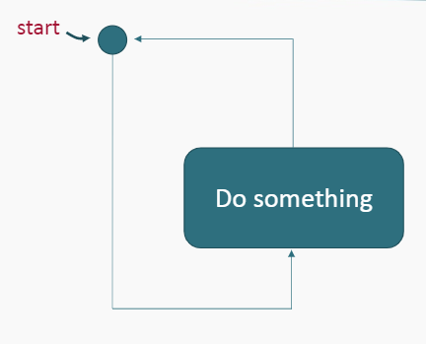
This loop will “Do Something” forever. This is called an infinite loop. It will crash your program. How can we stop it? We need a conditional statement / Boolean expression to get it to stop.

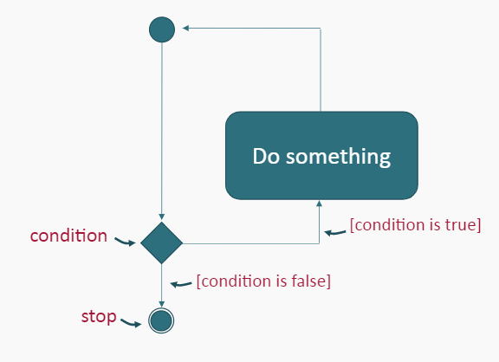
The first type of loop is a pre-test loop. In this case, the condition is tested before the code within the loop block is run for the first time.

For example:
Create a flowchart for a program that asks the user for a rating between 1 and 5, then print the number of stars representing the rating.

Solution:
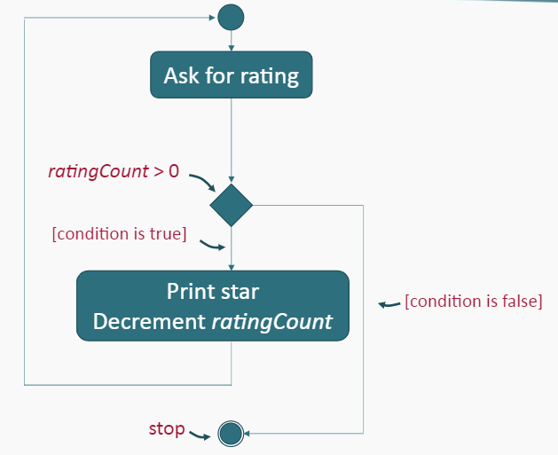
Sentinel Values
- A Sentinel Value is a special value used to terminate a loop.
- You typically choose a sentinel value as something that is not legitimate data value while the loop is iterating.
- In the loop that asks the user for a correct password, the sentinel value would be the value of the correct password This is the value which causes the loop to terminate.

Accumulators
- An Accumulator is a variable that accumulates the values of data in a program. Accumulators are typically used for counting and totaling.
- Accumulators can be incremented with any of the following statements:

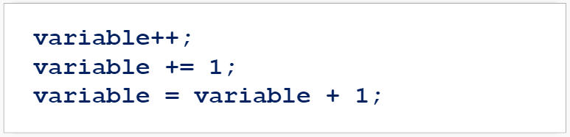
While Loop
A While Loop is a pre-test loop.
- In a pre-test loop, conditions of the loop are tested before the code is run.
- In a While Loop, a statement or statements are repeated while a condition is true.
- The loop stops when the condition evaluates to false.
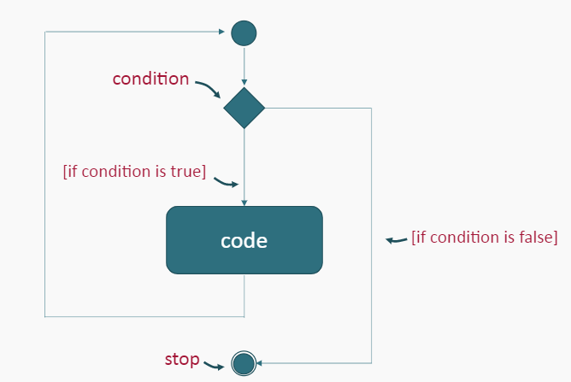

NOTE: A single execution of a loop is called an iteration

While Loop Syntax:
Example:
What is the output of this code? (Code uploaded to github)
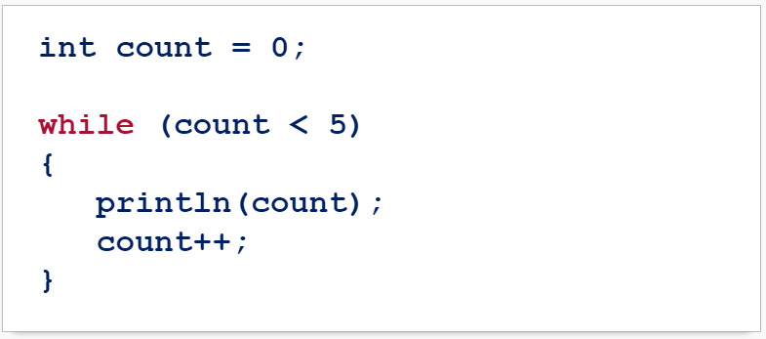

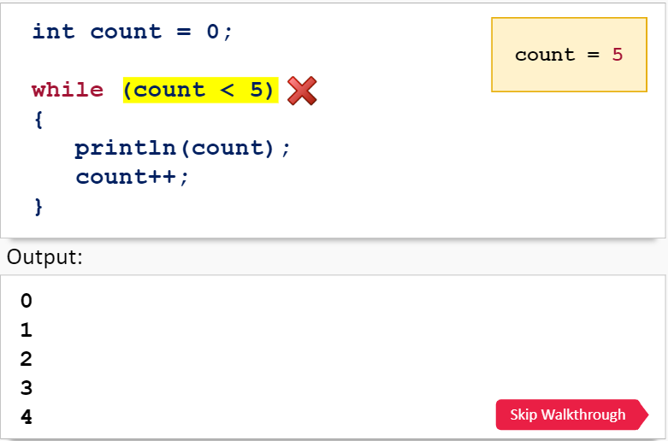
Walking Through the While Loop:

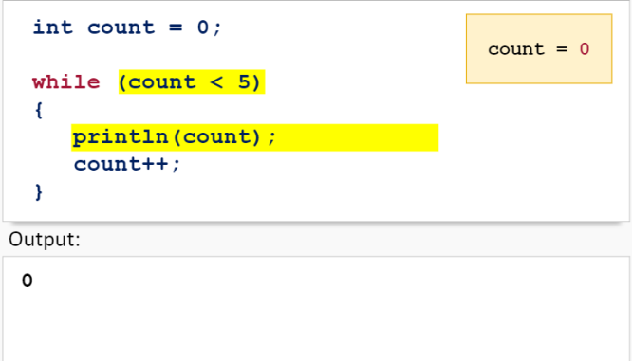

What is the output to this code?
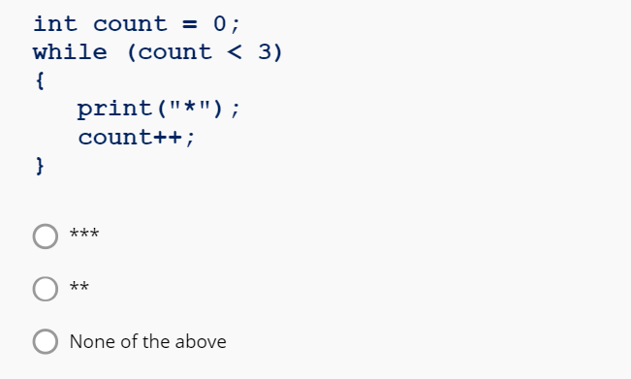

What is the ouput to this code?
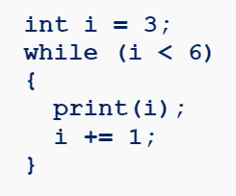
What is the ouput to this code?
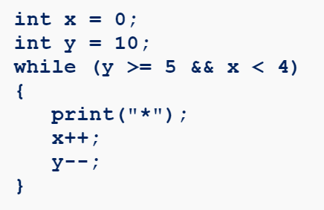

What is the ouput to this code?
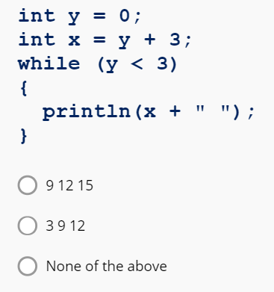
TRY IT YOURSELF

Create a sketch that displays stars for any given rating.
This sketch must:
- Ask the user for a rating between 1 and 5.
(Remember to parse the input to an integer)
- Use a while loop so that for each number of the rating, print out a star symbol or image.
For example: if the user inputs a rating of 2, your program should output: **

TRY IT YOURSELF

Create a sketch that uses loops, if statements and images to create a tug of war game that looks similar to this:
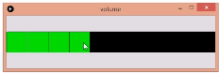

While Loop Exercises

- Using a while loop print the following pattern.

1
1 2
1 2 3
1 2 3 4
1 2 3 4 5

- Accept a number (integer) from the user and calculate the sum between 1 and that number.

- Ask the user for a number (integer) and create a multiplication table (1 to 12) for that number.

- Display the first 10 Fibonacci numbers.

(Hint: the Fibonacci number start with to 1’s, the next term is calculated by adding the 2 previous numbers. (1 + 1 =2, 1 + 2 = 3, 2 + 3 = 5…))

