Parallel Arrays
Parallel arrays, can also be referred to as a structure of arrays (or SoA) is a data structure that uses multiple arrays to represent a single data record. It keeps a separate, homogenous (the same data type) for each field of the record, with the corresponding elements all with the same index.
In other words, parallel arrays are 2 or more arrays that are the same length and whose elements are related by their indexes.
For example, if you had two String arrays, firstNames[] and lastNames[], a person's first name would be stored in firstNames[0] and that same person's last name would be stored in lastNames[0].
Think of parallel arrays like columns in a spreadsheet.
For example:
We want to store the first name, last name and height of a group of people. Since there are 3 fields of data, we declare and populate 3 arrays.
String firstName[] = {“Joe”,”Bob”,”Frank”, “Hans”};
String lastName[] ={“Biden”,”Dylan”,”Sinatra”,”Zimmerman”};
int height[] = {169,158, 201, 199};

All the elements with the same index value are associated with the same data record.
To access the entire record, process the arrays simultaneously.
For example:
for (int i=0; i<.firstName.length; i++)
{
println(firstName[i] + “ “ + lastName[i] + “ height = “ + height[i] + “cm”)
}

Output:
Joe Biden height = 169cm
Bob Dylan height = 158cm
Frank Sinatra height = 201cm
Hans Zimmerman height= 199cm

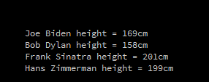
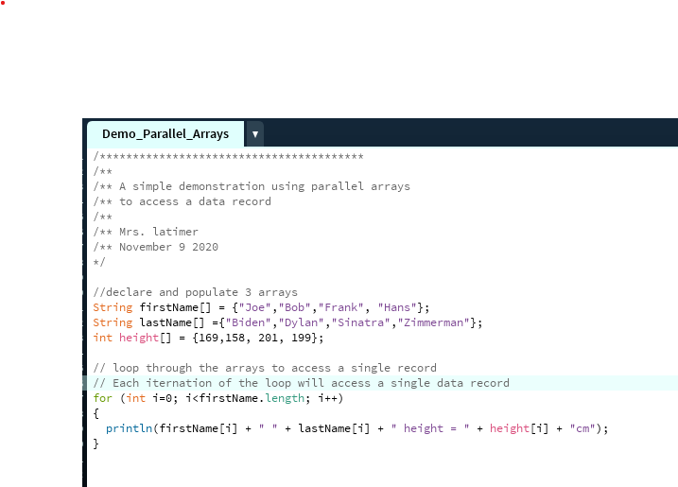

We can search the array for a specific value or range of values in any one of these fields.

TRY IT YOURSELF

- Update the sketch above to print the first name, last name and height of any person over 170 cm.

- Update the sketch above to print the first name, last name and height of any person greater than the average height

Parallel Array Exercises

- Write a sketch that declares and populates parallel arrays with student data according to the table below. In a separate function print the data for each student with a calculated letter grade.

Student Number | Student Name | Final Grade
1536 | Bob Benson | 78
7635 | Jake Peralta | 65
3425 | Sheldon Cooper | 99
4586 | Tony Soprano | 55
6436 | James Bond | 77
8750 | Heather Little | 86
2356 | Ada Lovelace | 99

Letter Grades:

0-49 | F
50-59 | D
60-69 | C
70-79 | B
80-89 | A
90-100 | A+

- Write a sketch that stores temperatures for five cities Manitoba. Record the city names in an array, the low temperatures in an array, and the high temperatures in an array. You may find the data on a weather service website. After recording all the data, display the average high, the average low, a list of cities with high temperatures above the average high, and a list of cities with low temperatures below the average low.

